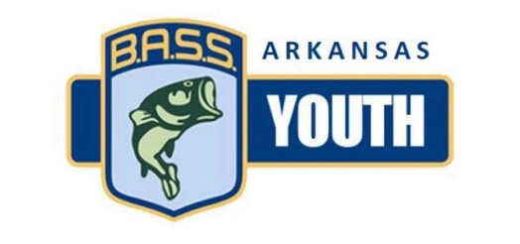

**Championship**

**May 02-03, 2020--Dardenelle**

**Ramp: Dardenelle State Park**

APRIL 5TH, 2020- Quachita

RAMP: CRYSTAL SPRINGS RAMP

US 270 West, Royal, AR. 71968

Crystal Springs Resort

1647 N. Crystal Springs Rd.

Royal, AR. 71968---(501)991-3361

MARCH 29TH, 2020- NORFORK

RAMP: PANTHER BAY MARINA

151 Panther Bay Loop, Henderson, AR. 72653

Lake Norfork Resort

9883 US-62

Henderson, AR. 72544---(870)488-5144

NOVEMBER 3 RD, 2019- AR RIVER DUMAS

RAMP: PENDELTON RAMP

426 AR-212, Dumas, AR. 71639

Days Inn by Wyndham Dumas

501 Highway 65 South

Dumas, AR. 71639---(870)382-4449

FEBRUARY 23ND, 2020- MILLWOOD

RAMP: YABOURGH LANDING

Pump Station Rd, Ashdown, AR. 71822

Wyndham Garden Texarkana

5301 N State Line Ave.

Texarkana, TX. 75503---(903)792-3222

SEPTEMBER 8TH, 2019-LAKE HAMILTON

RAMP: HULSEY FISH HATCHER RAMP

350 Fish Hatchery Rd. Hot Springs, AR. 71913

Baymont Inn & Suites

5321 Central Ave.

Hot Springs, AR. 72777---(501)520-5522

SEPTEMBER 22nd, 2019- DARDENELLE

RAMP: DARDENELLE STATE PARK

100 State Park Dr. Russellville, AR. 72802

Best Western

2326 N. Arkansas Ave.

Russellville, AR. 72802—(479)967-1000

Northern Division

Southern Division

**2019-2020 SCHEDULE**

**EXCITING New Format- Two Divisions!**

MARCH 1st, 2020- GREER’S FERRY

RAMP: DEVIL’S FORK

Higden, AR. 72067

Sportsman Lodge

7650 Edgemont Rd.

Higden, AR. 72067---(501)825-7600

NOVEMBER 24th, 2019- BULL SHOALS

RAMP: 125 MARINA

159 Lake Front Pt.-Peel, AR, 72668

The Wagon Wheel Resort

204 Wagon Wheel Ln

Peel, AR. 72668----(870)436-5401